**Public Conveniences** – Gosport Harbour Ferry.

Gosport High St (Near Morrisons).

Stokes Bay (By Sailing Club)

Adjacent The Diving Museum Stokes Bay Road.

**Printed by – BetaPrint PO12 1 JB Map Artwork – Jasper Smithers PO12 3JX**

**GOSPORT SOCIETY**

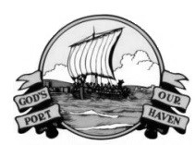

**Useful Tour Guide for residents & visitors to Historic Gosport, Hampshire. UK**

**WALK, CYCLE or PUBLIC TRANSPORT**

Visit [www.gosportsociety.co.uk](http://www.gosportsociety.co.uk) for Photographic Library of Gosport over the centuries & decades.

2024